NO. _______________ JEFFERSON CIRCUIT COURT
DIVISION _____________
JUDGE ____________________

MOHAMED AMBURE PLAINTIFF

v. COMPLAINT

PROGRESSIVE CASUALTY INSURANCE COMPANY
Serve at:
CT Corporation System
306 West Main Street, Suite 512
Frankfort, KY 40601

and

USAA CASUALTY INSURANCE COMPANY DEFENDANTS
Serve at:
CT Corporation System
306 West Main Street, Suite 512
Frankfort, KY 40601

* * * * * * *

Comes the Plaintiff, Mohamed Ambure, (hereinafter referred to as “Plaintiff”), by and through counsel, and for the causes of action against the Defendant, PROGRESSIVE CASUALTY INSURANCE COMPANY, (hereinafter referred to as “PROGRESSIVE”), and Defendant, USAA CASUALTY INSURANCE COMPANY, (hereinafter referred to as “USAA”), states as follows:
ALLEGATIONS COMMON TO ALL COUNTS
- That Plaintiff is now and was at all times relevant to the allegations set forth herein a resident of Louisville, Jefferson County, Kentucky.
- That Defendant, PROGRESSIVE, is and was authorized by the Department of Insurance of the Commonwealth of Kentucky to issue personal automobile policies in Kentucky and said Defendant was doing business in Jefferson County, Kentucky.
- That Defendant, USAA, is and was authorized by the Department of Insurance of the Commonwealth of Kentucky to issue personal automobile policies in Kentucky and said Defendant was doing business in Jefferson County, Kentucky.
- That the amounts in controversy exceed the minimum jurisdictional requirements of this Court.
- That Venue for this action is proper in Jefferson County, Kentucky, where Plaintiff resides and sought medical treatment for his injuries resultant from the subject motor vehicle collision.

COUNT I
COUNTS AGAINST DEFENDANT PROGRESSIVE FOR PERSONAL INJURY PROTECTION BENEFITS

- The Plaintiffs restate and re-allege each and every count set forth above as if fully set forth herein, and further allege:
- That on or about September, 18, 2012, Plaintiff was involved in a motor vehicle collision which caused him to suffer injuries on and about his body.
- That upon information and belief, Defendant, PROGRESSIVE, had in effect at the time of the collision described previously herein a policy of insurance under the terms of which the vehicle in which the Plaintiff was traveling and which afforded personal injury protection coverage to the Plaintiff pursuant to Sub-Title 39, Chapter 304 of the Kentucky Revised Statutes and more commonly known as the Kentucky Motor Vehicle Reparations Act (hereinafter "KMVRA").
- That under the provisions of said policy and pursuant to the provisions of Sub-Title 39, Chapter 304, Plaintiff was and is entitled to personal injury protection benefits in the minimum amount of $10,000.00.
- That the Plaintiff, as a result of the injuries sustained in the collision, has so far, and through the date of the filing of this Complaint, incurred reasonable and necessary medical expenses related to the collision in this instance.
- That the Plaintiff has furnished Defendant, PROGRESSIVE, with proof of medical expenses and losses as required and have at all times been ready, willing, and able to furnish Defendant with such further additional proof as may be required by the insurer.
- That Defendant, PROGRESSIVE, has received reasonable proof of fact and amount of loss realized as required by KRS § 304.39-210.
- That pursuant to KRS § 304.39-210(1), “benefits are overdue if not paid within thirty (30) days after the reparation obligor receives reasonable proof of the fact and amount of loss realized.”
- That Defendant, PROGRESSIVE, has not paid, continues to refuse to pay, or has only paid a portion based upon unilateral assertions, of Plaintiff’s medical bills beyond the required thirty (30) day window established pursuant to KRS § 304.39-210(1).
- That pursuant to KRS § 304.39-020(5) “There shall be a presumption that any medical bill submitted is reasonable.”
- That Defendant, PROGRESSIVE, has refused to pay some or all of Plaintiff’s medical bills despite receiving documentation from Plaintiff’s medical provider and continued cooperation by the Plaintiff.
- That Defendant, PROGRESSIVE, has based its refusal to pay Plaintiff’s medical bills in full without statutory or case law support.
- That Defendant, PROGRESSIVE, has not petitioned the circuit court to conduct a physical examination of Plaintiff and has not shown good cause why the court should order the Plaintiff to undergo physical examinations pursuant to KRS 304.39-270.
- That Defendant, PROGRESSIVE, in refusing to pay said medical expenses, has breached and remains in breach of the terms of the PROGRESSIVE policy inuring to the benefit of the Plaintiff, and has violated and continues to violate the applicable provisions of Sub-Title 39, Chapter 304 of the Kentucky Revised Statutes, and has failed and continues to refuse to comply with the applicable provisions of the Commonwealth of Kentucky Insurance Code.
- That, as a direct and proximate cause of Defendant, PROGRESSIVE’s, violation of KRS § 304.39-210 and unreasonable delay and/or denial in paying Plaintiff’s basic reparation benefits, Plaintiff has suffered damages, and has been forced to institute this lawsuit because of Defendant’s failure to make payment of their reasonable and necessary medical expenses.
- That, as a further direct and proximate result of Defendant, PROGRESSIVE’s, violation of KRS § 304.39-210, as described, Plaintiff has been compelled to retain the services of counsel in an effort to enforce compliance with KRS § 304.39-210 and thereby incurred and will continue to incur legal fees and costs, the full nature and extent of which are presently unknown to the Plaintiff.
- That the acts of Defendant, PROGRESSIVE, set forth above were and are willful, without reasonable foundation and therefore, in violation of KRS § 304.39-210 entitling the Plaintiff to interest at the rate of eighteen percent (18%) per annum under same statute and KRS § 304.39-220 et. sec., including reasonable attorney's fees.
COUNT II
CLAIM AGAINST DEFENDANT USAA FOR BODILY INJURY BENEFITS
- Plaintiff herein realleges and incorporates the foregoing allegations as if set forth specifically herein, and further allege:
- That on or about September, 18, 2012, Plaintiff was involved in a motor vehicle collision which caused him to suffer injuries on and about his body.
- That Plaintiff suffered damages, both mental and physical, including mental and physical pain and suffering, bodily injury, and medical expenses to date and in the future.
- That the amount of damages suffered by Plaintiff exhausts and exceeds the amount of personal injury protection benefits due to Plaintiff.
- That at the time of the collision referred to herein, Defendant, USAA, had in effect an insurance policy for the vehicle which struck Plaintiff’s vehicle, and said policy afforded bodily injury benefits for damage and injury caused by the covered vehicle if at fault.
- That the Plaintiff gave the Defendant, USAA, due notice of the collision, the injuries sustained, and the medical treatment required.
- That Defendant, USAA, has denied or failed to accept Plaintiff’s claims under claim number 016678528-1.
- That the Plaintiff has served discovery requests upon Defendants, USAA and PROGRESSIVE, simultaneously with the service of this Complaint.
WHEREFORE, Plaintiff demands judgment against the Defendants, as follows:
- Judgment against PROGRESSIVE for all unpaid medical expenses for the Plaintiffs (or such other amounts as may be proven in evidence the Defendant is obligated to pay pursuant to the KMVRA), plus a further judgment for all other reasonable and necessary medical expenses which the insurer has refused to pay or may later refuse to pay in breach of its obligations under its contract of insurance and applicable law;
- Pre and post-judgment interest against Defendant, PROGRESSIVE, at the rate of eighteen percent (18%) per annum on all unpaid benefits from the date proof of loss was submitted until paid;
- Pre and post-judgment interest against Defendant, USAA, at the highest rate allowed by law;
- Judgment against USAA for Bodily Injury Benefits in such an amount that will reasonably compensate Plaintiffs for physical and mental pain and suffering, past, present and future;
- Judgment against USAA for Bodily Injury Benefits in such an amount for payment of Plaintiffs’ medical expenses, past, present, and future necessitated by the injuries suffered, which exceed $10,000;
- Judgment against USAA for Bodily Injury Benefits in such an amount for payment of any lost wages of Plaintiff;
- Costs, expenses, and reasonable Attorney fees herein expended against either or both Defendants;
- Trial by jury on all issues so triable;
- Leave to amend this Complaint to add any additional claims, causes of action, or to join any additional parties as necessary or appropriate; and,
- Any and all other relief to which the Plaintiff may appear entitled.

Respectfully submitted,

MURPHY & POWELL PLC

________________________
Ross Benjamin Neuhauser
Aaron Michael Murphy
455 South 4th Street
Suite 1445
Louisville, KY 40202
Phone: (502) 473-6464
Fax: (502) 473-6462
Counsel for Plaintiffs

EXHIBIT A

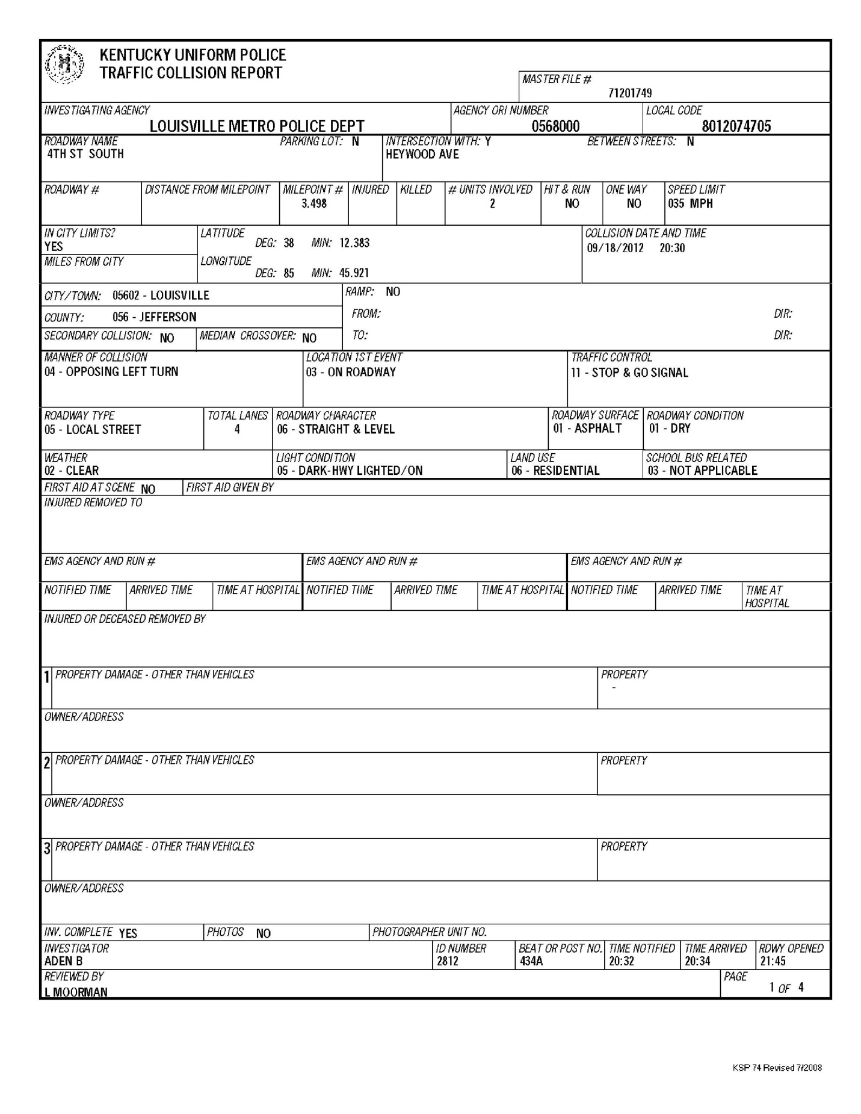

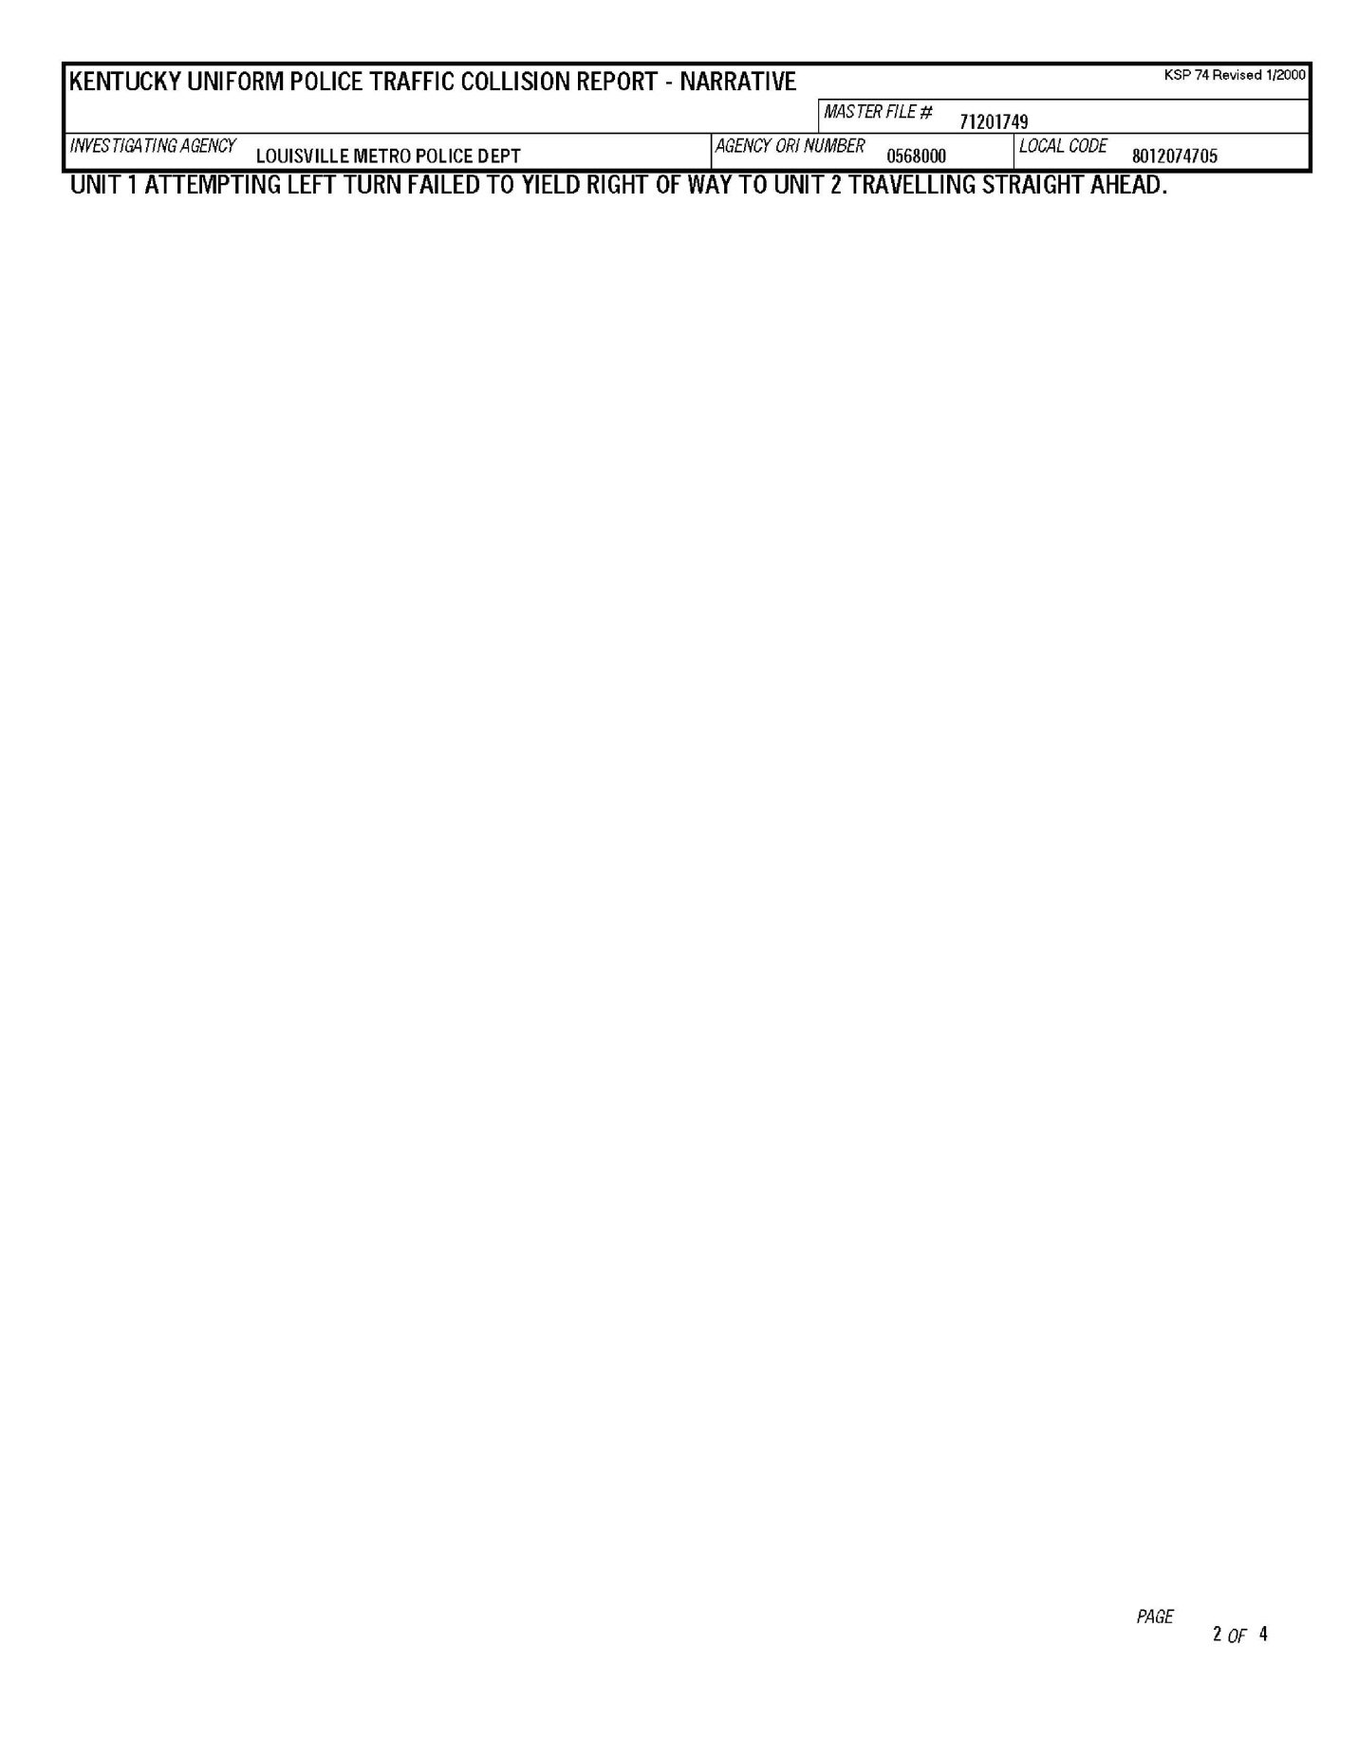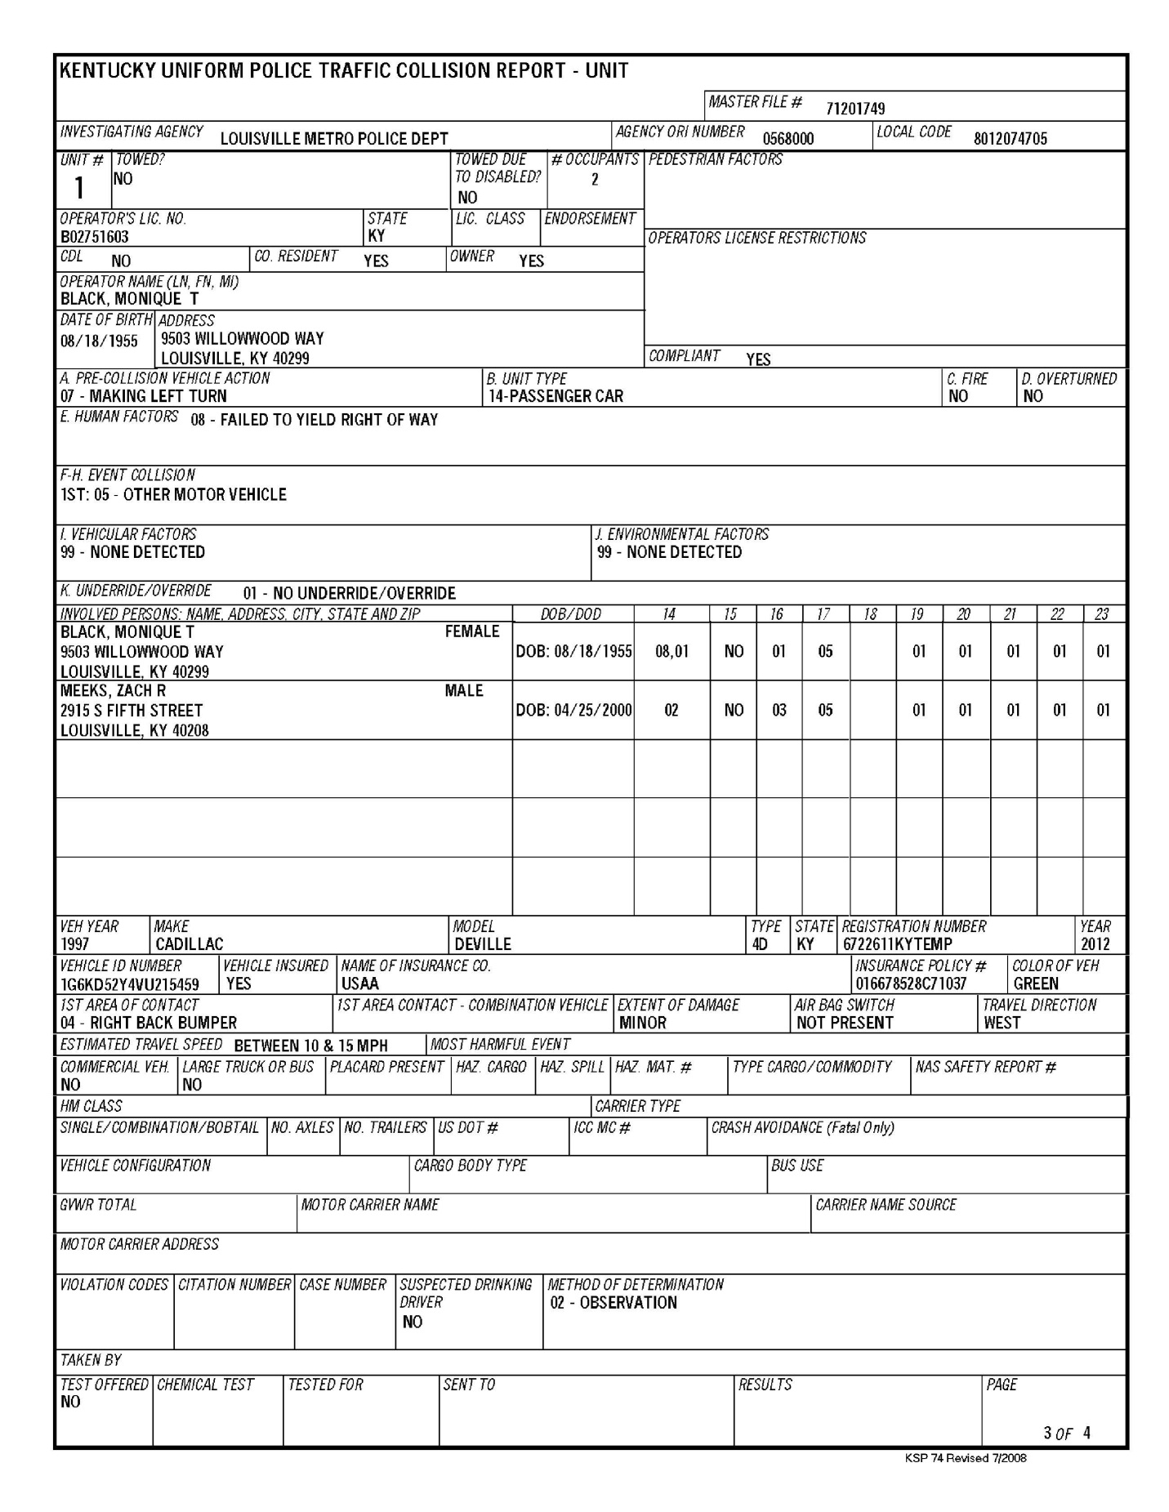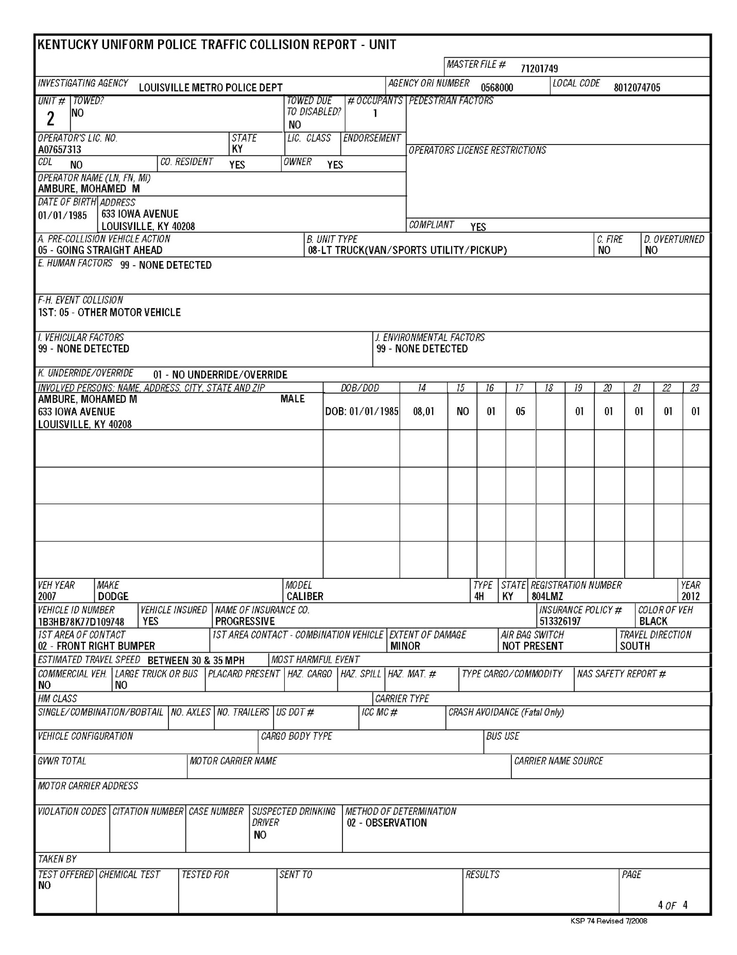

A copy of the Police Report for this motor vehicle collision is attached hereto and incorporated by this specific reference as Exhibit “A”.
See foot note 1.

